**OSCILLATING TOWER FANS:**

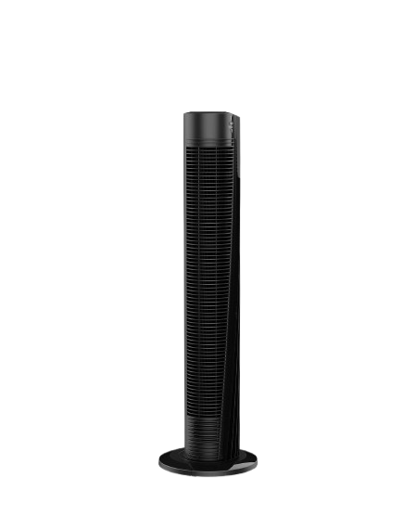

**Price: 7,000.00**

The Oscillating Tower Fan is a sleek and modern cooling solution, designed to provide wide-range airflow and maximum comfort. With its oscillating feature, this fan gently sweeps from side to side, distributing cool air evenly throughout the room. Its slim tower design, adjustable speed settings, and quiet operation make it perfect for bedrooms, living rooms, and offices, providing a refreshing and relaxing atmosphere with minimal distraction.

**Key features of oscillating tower fans include:**

* **Oscillation**: Evenly distributes air across a wide area.
* **Slim Design**: Space-saving and compact.
* **Multiple Speeds**: Adjustable airflow for personalized comfort.
* **Quiet Operation**: Low noise for a peaceful environment.
* **Energy Efficient**: Consumes minimal power.